HackerRank Program 9
Link :- https://www.hackerrank.com/challenges/find-digits/problem

Successful Submission
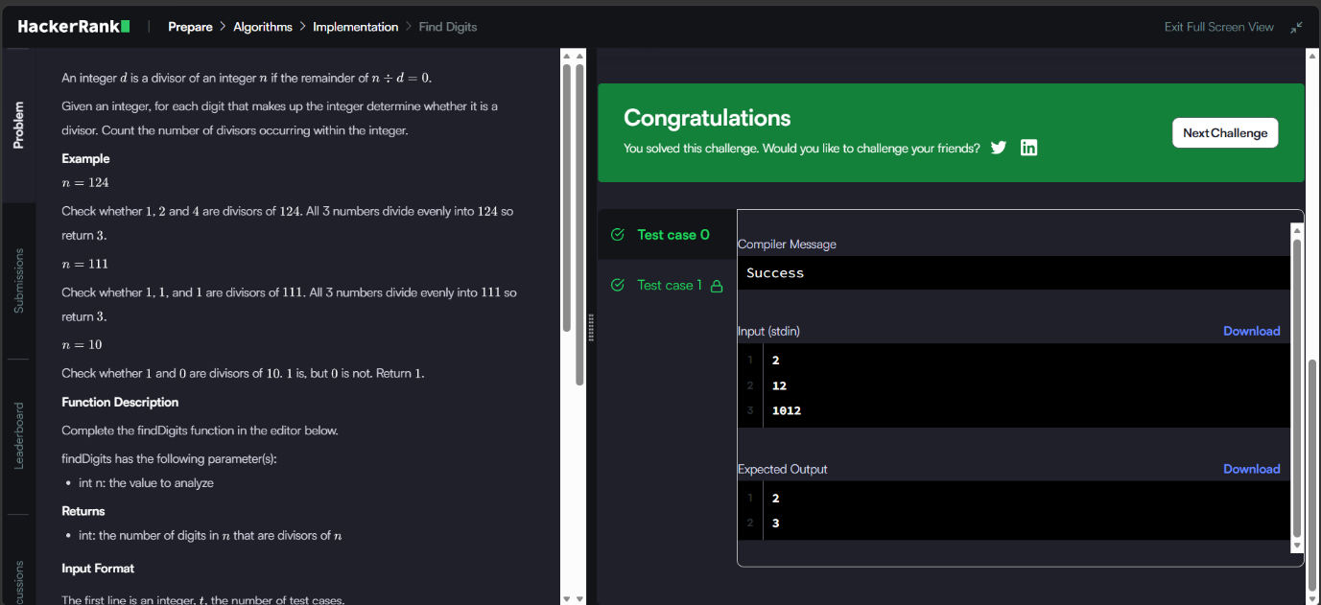
Source Code


